
Guide for software integration with automation API 6.0
October 2024
Document Version: 6.0

Contents
Introduction 4
Recent process and support changes of note 4
About this document 4
Summary of changes for API guide version 6.0 5
Overview 6
Accounts return (AR) submission process 6
Timelines for the live online form 7
Draft trust financial statements process 7
Budget forecast return process 8
Registering your software product 9
Annual update of client secret ID’s 10
Getting an OAuth 2.0 access token 14
Step 1: Invoke the Authorisation endpoint 14
Step 2: Receive authorisation results 17
Step 3: Exchange authorisation code for access token 17
Step 4: Refreshing an access token 19
Step 5: Calling the Financial Return Submission API 20
API specification for financial return submission 22
Draft trust financial statements 23
Budget forecast return (BFR) 23
Data requirements for submission 25
Data validations 27
Data set information 28
The importance of trust status and data types 29
API version 29
API endpoints 29
Create or update Submission 29
Delete Submission (available for testing purposes only) 34
Get submission (available for testing purposes only) 35
Test environment details 38
Supplier test (STE) 38
Test accounts 39
Academies Chart of accounts (ACoA) 40
ACoA version 40
API Validations on ACoA Version 40
Format requirements 41
Version validation 41
ACoA version change logic 41
ACoA account code structure 42
Glossary 44
HTTP status codes 46
API error codes 47
AR203/24 release changes 48
Document control 49
Appendix 53
FMS API validations 53
Json schema validation 53
Data validation 59
API Details 62

Introduction
Since 2020 the Department for Education (DfE) has improved end-to-end financial reporting for academy trusts (trusts). As part of this work, the DfE has developed an application programming interface (API) to support the automated submission of a trusts trial balance data via their financial management system (FMS). This automated data submission is based on a standardised academies chart of accounts structure which academy trusts must either adopt or map to.
The data submitted via the API will be used to pre-populate the academies account return which trusts are required to submit to the DfE. This will deliver benefits across the sector by saving time and costs of submitting financial data.

Recent process and support changes of note
- We created a supplier helpdesk to help support developers and FMS suppliers
- The ‘developer hub’ has changed to ‘Find and Use an API’
- The test environments have been streamlined, UAT and Pre-production are no longer available, only STE and Production are used
- Supplier test trusts have been reduced and renewed following the move from mailinator and IDAMS onto DfE Sign In (DSI)

About this document
The document will serve as a helpful guide for software suppliers to help prepare for the integration with the API and applies to the API that is to be used with AR23/24 collection.
The document contains details relating to both the consent process and the financial return submission API itself.
This document is intended for use by business analysts, technical architects, and software developers from software supplier organisations. To find out more about the academy accounts return online form use this link.
If FMS providers have any questions about this document, or need further help or information, visit our help centre to view our knowledge base and raise a ticket if needed: DfE Chart of Accounts and Automation (education.gov.uk)

Summary of changes for API guide version 6.0
New sections added -
- 2 sections relating to Budget Forecast Returns
- The importance of trust status and data types
- Test accounts
Section removed -
- UAT environment sections and links removed
Other -
- Updates to environment links in Appendix > API Details section
- Updated links in ‘Supplier test (STE)’ section
- API base URL for STE
- Front end on-line collections STE URL
- Scope URL changed from preprod to prod tenent
- New link to our supplier helpdesk
- Update to DfE temporary account codes
- Wording change from ‘CoA’ to ACoA’ throughout. (Academies chart of accounts to differentiate from further education CoA)
- Name changed from ‘Developer hub’ to ‘Find & Use an API’
- Link for developer hub changed to ‘Find and Use an API’

Overview
This API is designed to support academy trusts with completion of financial returns to DfE. This is normally done using an online form allowing the trust user to fill in the details and get immediate feedback of any issues. By using this API, the trust can transfer much of the information directly from their finance software saving time and helping to ensure better accuracy.

Accounts return (AR) submission process
The following diagram shows the different stages in the completion and submission of the AR form:
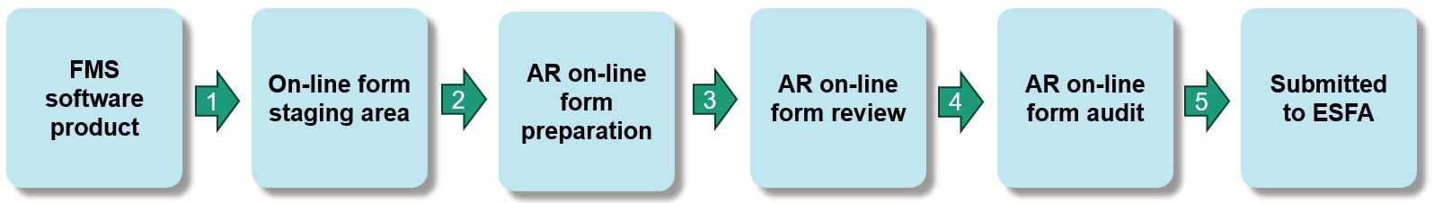
- Process 1: API used here to transfer data to the online form staging area. There is only ever one set of data stored and it can be updated/overwritten
- Process 2: The trust preparer will need to use the form to ’accept’ data from an API to be used to prepopulate the AR form.
- Process 3: The trust preparer reviews the automated data which can be modified, adds the remaining data to complete the whole AR form, and submits for review.
- Process 4: Once the internal review is successful the trust can submit the return for external review by auditors.
- Process 5: Only once the auditor has approved the AR form can the data be submitted to DfE.
The API described within this document is used on the first stage allowing trusts to transfer a set of data across to the online form staging area. Once received, the trust preparer can choose whether to use the data to pre-populate the online form.

Timelines for the live online form
The planned timelines for the availability of the ESFA automated financial on-line form 2023/24 are as follows:

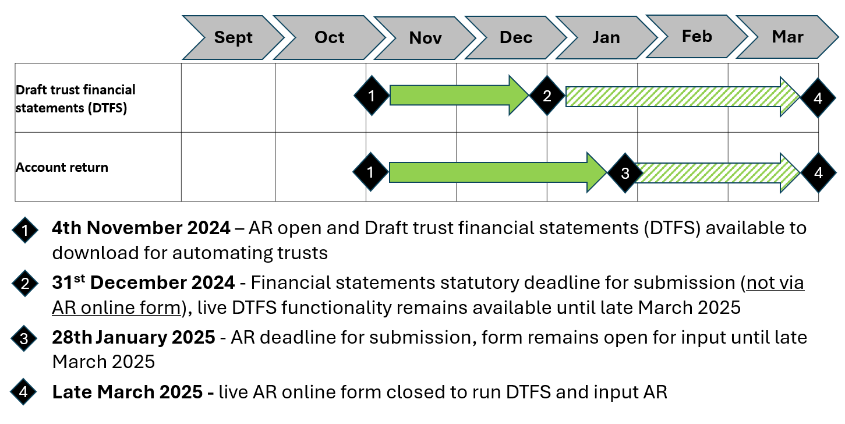

Draft trust financial statements process
The draft trust financial statements report is available via the live AR on-line form.
The following diagram shows the different stages in the generation of the draft trust financial statements report:

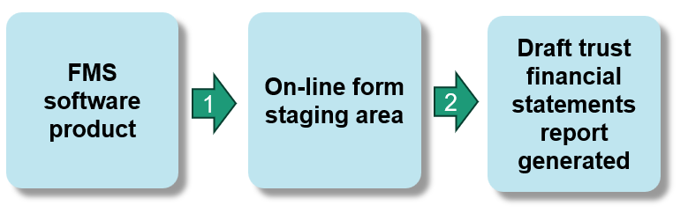
- Process 1: API used here to transfer data to the online form staging area. There is only ever one set of data stored and it can be updated/overwritten
- Process 2: From within the online form, the trust preparer clicks on the ‘Draft trust financial statements’ link to populate the draft trust financial statements report with the latest API data set transferred

Budget forecast return process
Automated financial data that has been sent to the accounts return using the API, is now being used by the DfE to prepopulate the equivalent financial years data in the budget forecast return (BFR).
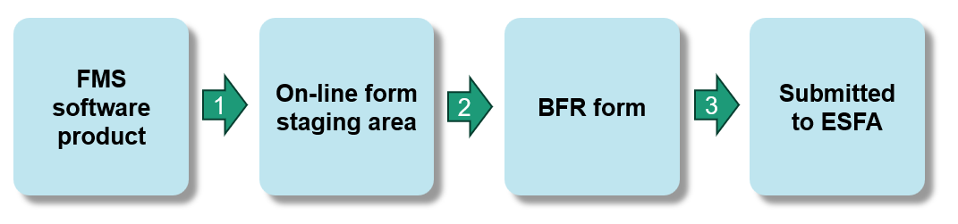
- Process 1: The last API sent to the previous accounts return and is held in the DfE’s on-line staging database (process already taken place)
- Process 2: The DfE takes the data stored in the on-line staging database to pre-populate the first 3 columns of the BFR, using the most recent mapping for the Academies CoA to BFR fields for the equivalent financial year.
- Process 3: The trust can modify the mapped data before fully completing and approving the form, then submitting to the ESFA

Registering your software product
Before calling the API, a software supplier will need to register their software with DfE. This is an important step in the standard authorisation process and allows us to issue unique codes to that software product. The following information will need to be provided to the DfE for each product to be registered:
- Name of the product (which should be unique for that software organisation).
- One or more redirect URLs which must be full URL strings. These are pre-registered addresses to which an authorisation code is returned. Since our service will only accept pre-registered URLs, it will be necessary to define all redirect URLs for all environments for that particular software product. For more details please refer to standard OAuth 2 documentation. Note that only https is supported.
Once the software product is registered, DfE will provide client_id, client_secret and subscription_key which you will need to use as part of the subsequent process.
The DfE has introduced a self-service portal (developer hub) to register your software product and subscribe to the submission API. A software supplier can register the application and can generate the client credentials and also the subscription keys for the API. The user can add the redirect URLs to the application at any point of time.
– https://dfe-developerhub.education.gov.uk/
Link to the Find and use an API (formally DfE developer hub) :Home | Find and Use an API (education.gov.uk)
It is important to note that while software products will be pre-registered with the DfE, this will not include any assurance review. Therefore, registration does not act as offering an official approval for a particular software product.
Note: The suppliers can register the product using portal Home | Find and Use an API (education.gov.uk) and it will go through the approval process. Approval can take up to 5 working days.
For help and information, please use our help centre : DfE Chart of Accounts and Automation (education.gov.uk)

Annual update of client secret ID’s
For security reasons, the client secret used in the API will expire 2 years from the time it was last generated.
We recommend suppliers update their subscription keys annually as part of their ‘business as usual’ processes, which will also ensure you are using the most up to date contact details. This is a really quick and easy process, and guidance is provided below. Please note that this is an automated procedure and no approval process is involved.
For assistance, please use our new helpdesk and knowledge base: DfE Chart of Accounts and Automation (education.gov.uk)
How to regenerate your client secret ID
- Log into the Find and use an API using your existing account:

Home | Find and Use an API (education.gov.uk)
- Once logged in, click on ‘Application’
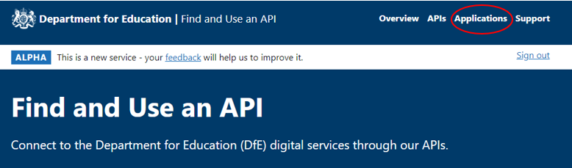

- In the left-hand menu, click on ‘Client secret’
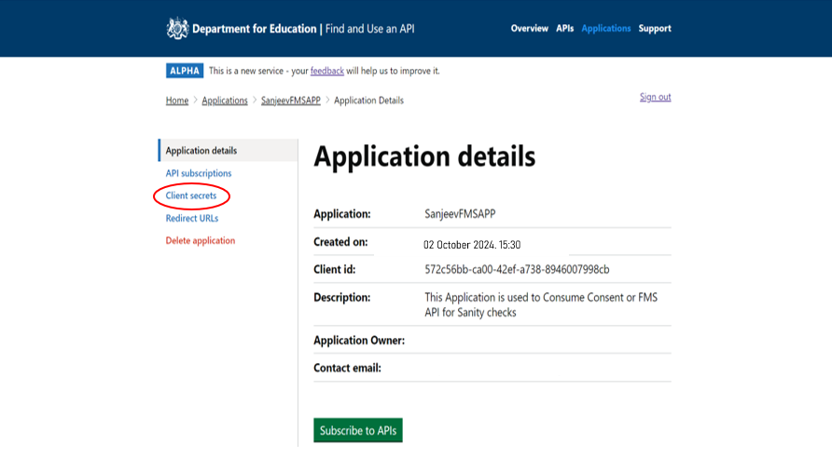

- Under the ‘Primary secret’ heading click on the ‘Regenerate’ button

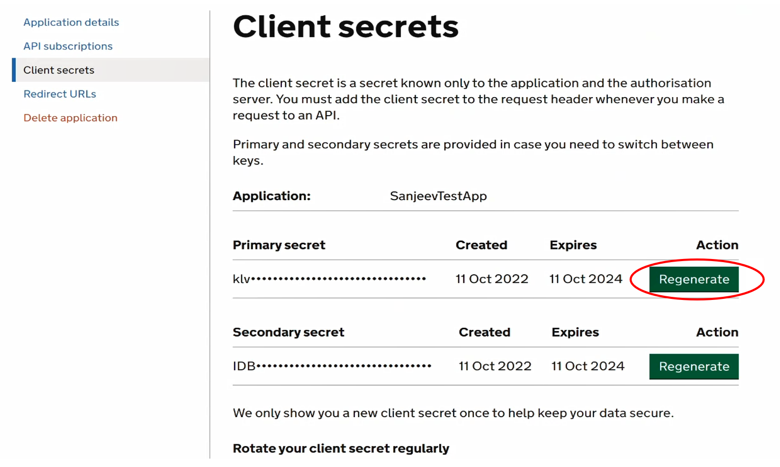

- You will then be presented with the screen below, please click on the ‘Continue’ button

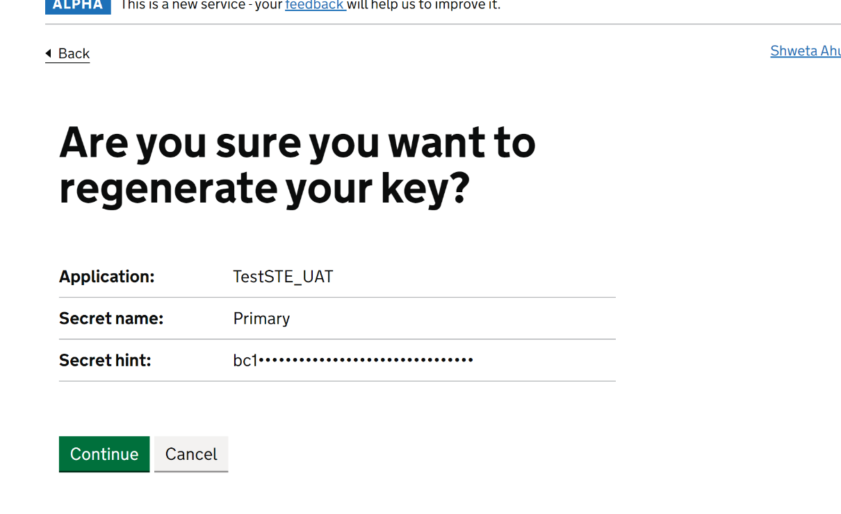
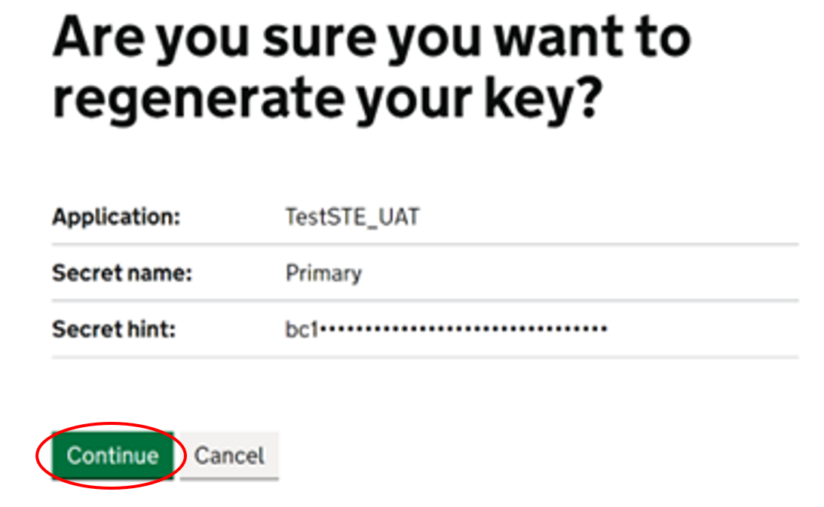
- You will then receive a message to say ‘Your primary key has been regenerated successfully’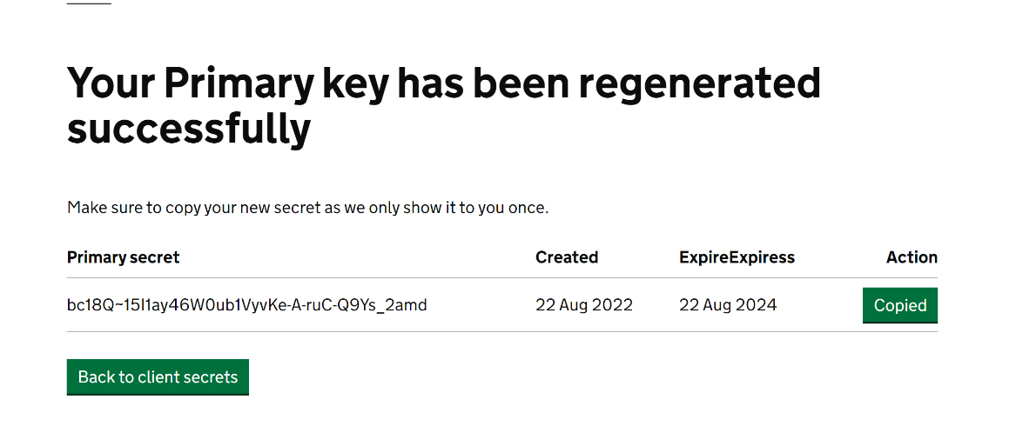

Getting an OAuth 2.0 access token
It is important to recognise that trusts retain ownership of this data so as a pre-requisite to calling the API, we ask that trusts approve the transfer of this data. The end user provides consent to connect with the DfE without sharing their access credentials. The end user who intends to provide that consent must have the specific role of ‘Data Transfer Approver’ (DTA) assigned in the DfE Sign In (formally IDAMS) identity management service.
We use the open standard OAuth 2.0 for API authorisation. Suppliers will need to implement the authorisation user journey listed below to receive the OAuth 2.0 access token.
! You must not modify this journey in any way.

Step 1: Invoke the Authorisation endpoint
You must call the authorise endpoint to invoke the consent approval process. Please note that you need to provide either UPIN or company number below, and not both.

GET https://{authorize_base_url}
&response_type=code
&client_id={client_id}
&redirect_uri={redirect_url}
&nonce=defaultNonce
&scope=openid offline_access {fms_api_scope_url}
&prompt=login
&upin={trust_upin}
&companyNumber={companyhouse_number}
&apifamily={apiFamily}
&state={state}

An example of the request to authorise endpoint is below:
https://dfeb2cprod.b2clogin.com/dfeb2cprod.onmicrosoft.com/oauth2/v2.0/authorize?p=b2c_1a_consent_dfe&client_id=740c9a67-066c-4c10-a1c5-63bc7c7844b5&nonce=defaultNonce&redirect_uri=https%3A%2F%2Fjwt.ms%2F&scope= openid%20offline_access%20 https%3A%2F%2Fdfeb2cpreprod.onmicrosoft.com%2Fbfrp-ar%2Fapi.submit&response_type=code&prompt=login&upin=770015&apiFamily=bfrp-ar&state=browser
! Do not include your client secret in this request.
Parameter | Description
response_type | The OAuth 2.0 response type. Currently the only acceptable value is code .
client_id | The client id associated with the FMS supplier application.  Please note that the client id is specific to the DfE Azure B2C environment and is different from any client id provided as part of integrated testing with DfE Sign In.
redirect_uri | The HTTPS URL that we use to send the authorisation results back to your application after successful (or unsuccessful) authorisation. The URL needs to be encoded e.g. https%3A%2F%2Fjwt.ms  This must match one of the redirect URLs specified during the application registration process.
scope | A space-delimited list of scopes you would like to have permission to access on behalf of your user. Must be percent-encoded, so spaces must be represented as either %20 or +.  openid offline_access {fms_api_scope_url}  E.g. in supplier test,  {fms_api_scope_url}=  https://dfeb2cprod.onmicrosoft.com/bfrp-ar/api.submit  The URL encoded scope would look like  openid%20offline_access%20 https%3A%2F%2Fdfeb2cprod.onmicrosoft.com%2Fbfrp-ar%2Fapi.submit
Nonce | A value to bind token to the client. The expected value is defaultNonce
prompt | Specifies whether the authorisation server prompts the End-User for consent. Currently the only acceptable value is login .
upin | Unique identifier for an academy trust. Must be six digits.
companynumber | Company House Number for an academy trust. Must be eight digits.  ! Please provide either UPIN or Company House Number as providing both will lead to error
apifamily | Currently the only valid value is bfrp-ar
State (optional) | An opaque value used to maintain state between the request and callback and to prevent tampering as described in the OAuth 2.0 specification. This is passed back to your application via the redirect_url.

This end point will open a HTML page where the user will be asked to login to the DfEs identity management service, DfE Sign In (formally IDAMS) . Having logged in, they will then be presented with a consent page asking for approval to the transfer of data via the API. The user who gives consent will need to have been assigned the specific role of ‘Data Transfer Approver’ in the DfE Sign Insystem, this would normally be done by the Trusts’ approver (previously the IDAMS Super User).
Trusts’ approver (previously the IDAMS Super User).

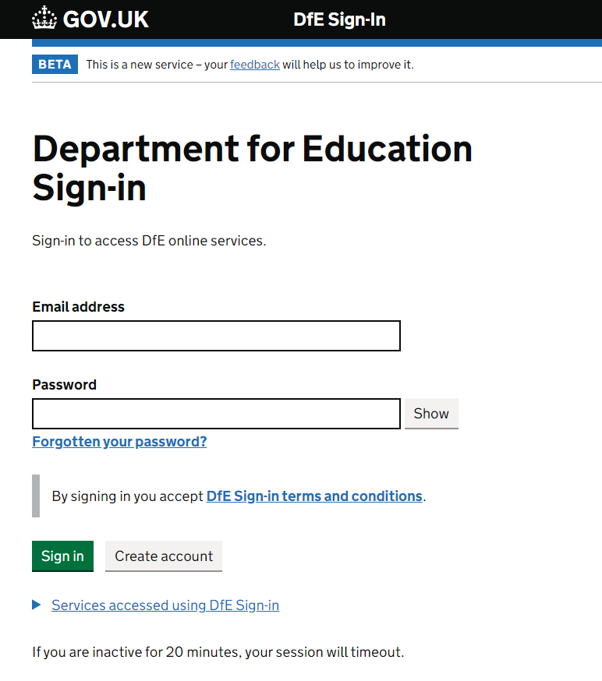
The user needs to login and give the consent to transfer the data.
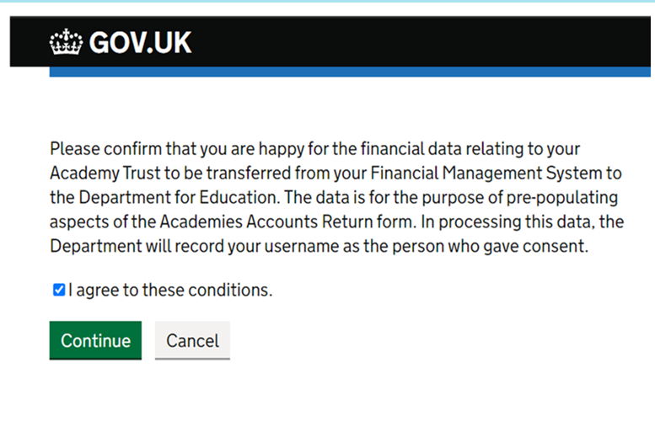

Step 2: Receive authorisation results
You need to create an endpoint in your application to receive the authorisation results, which needs to support an HTTP GET to the redirect URL you specified.
We’ll redirect the user’s browser back to your endpoint once the user has granted your application the requested authority.
This authorisation code is valid for 10 mins.
Example of the authorisation response:
GET https://{redirect_url}?code={authorisation_code}

In case of error, you will receive this response:
GET Error! Hyperlink reference not valid. description}
Please refer to OAuth2.0 error responses for the list of errors. You will need to incorporate appropriate error handling to display user friendly error messages to the end users.

Step 3: Exchange authorisation code for access token
When you receive the authorisation code, you must exchange this for an access token within 10 mins before it expires.
Do this via a POST to our token endpoint.
Include the request parameters in the request body as a URL encoded string, not as request headers.
Example of a request to exchange authorisation code
POST https://{token_base_url}
Request body:
Content-Type application/x-www-form-urlencoded
grant_type authorization_code
code {authorisation code}

scope openid offline_access {fms_api_scope_url}

client_id {client_id}

client_secret {client_secret}

Parameter | Description
grant_type | The OAuth 2.0 grant type. Currently the only acceptable value is authorization_code
code | The authorisation code you received from us in the previous step.
client_id | The client id associated with the FMS supplier application.
client_secret | The client secret associated with the FMS supplier application
Scope | openid offline_access {fms_api_scope_url}  E.g. in supplier test,  {fms_api_scope_url}= https://dfeb2cprod.onmicrosoft.com/bfrp-ar/api.submit.  The scope would look like  openid offline_access https://dfeb2cprod.onmicrosoft.com/bfrp-ar/api.submit

The response contains the access token used for calling the APIs and a refresh token used to obtain a new access token once the current one expires.
Access_token and id_token will expire after 10 minutes.
Example of a successful exchange response:
{
"access_token":"eyJhbGciOiJSUzI1NiIsInR5cCI6IkpXVCIsImtrZ..."
“expires_in”:”600,
"id_token":"eyJhbGciOiJSUzI1NiIsInR5cCI6IkpXVCIsImtpZ...",
"token_type":"Bearer",
"id_token_expires_in":600,
"scope":"openid offline_access",
"refresh_token":"MmZmNTMzMGYtZGRhYi00MDI1LWFiNWUtZjc2...",
"refresh_token_expires_in":3600,
}

Step 4: Refreshing an access token
When the access token expires, you will need to send a POST request to exchange a refresh token for a new access token. The response will include a new refresh token that will replace the previous one and must be retained and used the next time the access token expires.
Refresh tokens will expire after 60 minutes.
You should send the POST request to:

POST https://{token_base_url}
Request body:
Content-Type application/x-www-form-urlencoded
grant_type refresh_token
refresh_token {refresh_token}

client_id {client_id}

client_secret {client_secret}

scope openid offline_access {fms_api_scope_url}

Example of a successful token response
{
"access_token":"eyJhbGciOiJSUzI1NiIsInR5cCI6IkpXVCIsImtrZ..."
“expires_in”:”600,
"id_token":"eyJhbGciOiJSUzI1NiIsInR5cCI6IkpXVCIsImtpZ...",
"token_type":"Bearer",
"id_token_expires_in":600,
"scope":"openid offline_access",
"refresh_token":"MmZmNTMzMGYtZGRhYi00MDI1LWFiNWUtZjc2...",
"refresh_token_expires_in":3600,
}

! You must store your access and refresh tokens securely and not share them with anyone else.

Step 5: Calling the Financial Return Submission API
You will need to use the access token and subscription key to call the Financial Return Submission API
Example of a call to a user-restricted API
PUT /api/{resource} HTTP/1.1
Host: https://{api_base_url}/submissions
Authorization: Bearer {bearerToken} Ocp-Apim-Subscription-Key {subscriptionKey}
Parameter | Description
bearer_token | The access token that is used to grant access to user-restricted APIs. This is provided at Step 3 in exchange for the authorisation code and will expire after 10 minutes. If necessary, you can generate a new one using the refresh token provided. Bearer tokens are issued as access tokens of ‘bearer’ type.
subscription_key | The subscription key provided to you by DfE. Please note that the subscription key will change depending on the DfE environment (supplier test or prod) you are accessing

Please refer to the API specification in the next section for the content to be provided as part of the submission process via API.

API specification for financial return submission
The API enables academy trusts to send their trial balance financial data to the Department using 3rd party software. The API allows a single financial upload to be made which is placed in a holding area within the online form. This will not automatically update information within the online form. For this to happen an authorised user must use the online form to consciously apply it to the form. When this happens, the data supplied by the API will be used to pre-populate the appropriate calls. In cases where the level of detail required by the form is less than that provided through the API, then the pre-population process will sum the lower level values and only enter the summary total.
If users wish to upload a revised data set, this is also supported and will result in the original values being over-written.
About testing the API
When software suppliers are enhancing their software product to use our APIs, we recognise it is important to ensure the testing process can simulate live operation. We support API testing in the following way:
- A separate end point and authorisation service is provided to minimise the risk of using the wrong service (i.e. removing the risk of using the live API for testing or the test API in live).
- Software suppliers are assigned a small list of dummy trusts which represent the different types of trust they support (i.e. MATs or SATs)
- User accounts will be created in DfE Sign In for each dummy trust so that the software supplier can simulate the consent approval process as part of the testing.
- In addition to the API operation for submitting data there are two other REST methods which can be used to facilitate testing.
  - GET will allow the tester to re-read the file submitted and ensure it reflects the expected results
  - DELETE using submission GUID parameter will allow the tester to delete a submission before running the next test.
- For GET and DELETE endpoints, you will need to follow the same authorisation user journey to get the access token which further needs to be supplied as the bearer token as part of invoking the endpoints.

Draft trust financial statements
The draft trust financial statements functionality enables trusts to use the same FMS data sets and API functionality to populate the trial balance elements of their statutory financial statements.

No changes are needed by trusts and software suppliers in the preparation and processing of the data into the online form, specifically:

- There is no change to the data requirements that trusts are required to provide for submission from FMS to the API

- There are no changes needed to the API, therefore, there no changes required to be made to the source data requirements or the process to import data into the online AR form via the API

- The draft trust financial statements file uses the same ACoA version as the AR

- Prior year data columns within the workbook are populated from the final FMS data submission accepted into the AR form by the trust in the previous year, if they did not submit and accept data in the previous year, these columns will be blank. Therefore, FMS suppliers do not need to take any action to enable trusts to populate this data.

The draft trust financial statements will be available when the AR form is livefor those trusts who can automate their data. Please review the timelines in the ‘Overview’ section of this document.

Budget forecast return (BFR)
The budget forecast return (BFR) pre-population has been introduced so that trusts are able to use the same FMS data set they sent to complete their AR, to populate the outturn expenditure data required in the BFR.

No changes are needed by trusts and software providers in the preparation and processing of the data into the online form, specifically:

- There is no change to the data requirements that trusts are required to provide for submission from FMS to the API

- There are no changes needed to the API, therefore, there no changes required to be made to the source data requirements or the process to import data into the online AR form via the API

- The BFR uses the same ACoA version as the AR
- Data is pre-populated from the final API sent by the trust for the previous AR collection period.
However, please note that suppliers who provide their clients/trusts with reports to map the ACoA into BFR fields, should be mindful that the DfE’s published mapping may change and therefore corrections may be needed in your software to mirror the mapping that the DfE are using to pre-populate the BFR form.

Data requirements for submission
1. Each academy within the trust is identified by its Local Authority Establishment Number and this needs to be provided as an “id” for Academy level data in the body of the data upload. For the avoidance of doubt each LAE number should only appear once in the list; also please note point 6 below.
2. Counterparty data items must be tagged and identifiable as CounterpartyData. If you are unable to send them, the counterpartyData element in the JSON can be set to either empty brackets {} or omitted entirely.
3. MAT central services data items must be tagged and identifiable as matOverview. If you do not have this data, the matOverview element in the JSON can be set to either empty brackets {} or omitted entirely.
4. Data must be provided to a maximum of 3 decimal places. Data values with fewer decimal places are acceptable but data values with more will cause an error to be returned.
5. Data must be provided at the academy trust level as a consolidated figure against a Trust UPIN or Company House Number.
6. Only provide data for the ACoA items that have been populated in the FMS software. Where ACoA items have not been populated in the FMS Software, omit these items from the API submission. Do not provide null, nil, blank or zero values. This ensures the AR form correctly informs the user of which items have been automated by the FMS API upload process. To note, zero is not an acceptable value where the academy has expressly entered this.
7. Only DfE account codes should be included in the data upload, therefore where the trust has added their own local account codes, these values must be consolidated into the DfE account code for that range, for example, any account codes added in the 855601 to 855609 range should be consolidated up to 855600 ‘Non Educational Contracts’ for the FMS data upload. Also see ‘ACoA structure’ heading below.
8. Where recent changes have been made in the composition of a Trust, the list of academies provided in the API submission should only include those for which financial transactions were recorded at any point during the past academic year ending on the 31st August. Hence, if an academy joined the trust on the 30th August, then it should be included in the submission, but if it joined on the 1st September then it should be excluded.
9. Source system must be provided while submitting the data. Example of source system – “XXX Financial Systems”. This field is mandatory and is used for DfE internal reporting purposes (Registered software product name can be used)
10. The ACoA version was “6.0.0” for AR 2023 collection. This can change every year depending on the changes made to the ACoA codes. The ACoA version will be updated accordingly, the 2024 collection uses version 7.0.0.
11. If a trust wishes to take advantage of completing academy level tables, they must also submit data at central services and individual academy level.
12. If a trust has a trading subsidiary which is operating as part of the same legal corporate entity as the trust, this data will also need to be included in the API. For academy level data, the trust will need to decide whether to assign this to ’matOverview’ if the trading subsidiary applies to two or more academies, or ‘academies’ if the trading subsidiary is affiliated to one academy only.
13. The trust must be setup correctly as a MAT or SAT as appropriate, this ensures that the relevant data is sent through according to the trust type.

There are 2 types of validation being applied to the request.
- Json schema validation
- Data validation
Refer to Appendix section – FMS API validations for the details of all the validations.
The data requirements for the AR and the draft trust financial statements are the same.

Data validations
The following validations are performed during the API submission process:
- check if the submission is valid Json, and that it does not violate the Json schema
- check if the coaVersion is valid, example "7.0.0"
- check if the “coaElement” in the coaElement:Value pair is valid for the coaVersion
- check if the “Value” in the coaElement:Value pair is valid and numeric value
- check if the trial balance total is zero, for Trust level data
- check that each academy referenced in the body of the upload is recognised by the DfE as belonging to the trust
- check if 0 or null is passed where the field is blank. No 0’s will be accepted
- check if any duplicate ids/keys are sent in the json, duplicate id/keys will not be accepted
- check if source system is not null. Value provided must be between 2 to 50 characters. It can contain letters, numbers, ‘&’ and ‘- ‘. No other characters will be accepted. This information will be used for internal DfE reporting purposes and enable us to support the automation process. We therefore ask that you ensure the value entered is recognisable as your FMS
FMS suppliers should capture below information in their application:
- Environment which they are connected to (supplier test/STE or Production)
- API URL link and Token end point called from supplier application
- Date/time when API calls are made.
- User details, if possible. (User ID, trust UPIN, Trust name)
Above details help in providing an audit trail for the FMS suppliers technical team to diagnose user errors.
FMS suppliers should refer users to API error codes available in this guide.

Data set information
The four different types of data which can be sent via the API are:
- matOverview –
This data is collected to pre-populate the MAT Central Services area of the AR benchmarking tab. This is an unconsolidated viewpoint and shows how the MAT is operating as a central standalone function, including transactions with academies that belong to the trust itself.
MATs may provide services from their central trust to their academies – for example finance staff will be employed by the Trust but their work covers all academies. Often, but not always, this is funded by each academy in the trust making a contribution, and it’s up to the trust how they decide the allocation. Details of all the central income and expenditure, retained reserves and any centrally held assets need to be captured in the MAT Central Services tables within the benchmarking and land and buildings sections of the AR.
How you capture this is dependent on how your users normally account for central services. If they set up a separate entity for group/central services functions, then it is this data we would ask for.
- Academies –
This is academy level trial balance data which is used to pre-populate the individual academy sections in the AR benchmarking and land and buildings sections. As with the “matOverview”, this is an unconsolidated viewpoint and may include transactions with that MAT central services. A full trial balance for each academy can be sent and the AR form will pick out the data it requires.
- trustData –
This is the most important part of the submission which is used to pre-populate the majority of the AR form. This will be the full list of trial balance data at consolidated trust view and won’t include any of the transactions within the trust itself, unlike the areas mentioned above. The trial balance data must total to zero or the submission will be rejected by the API.
- Counterpartydata –
This details any transactions with other Trusts in the sector totalled by account code and is used to prepopulate the counterparty section of the AR form.

Depending on how your users can set up their entities (“group” services in particular), it may be that trustData = academies + matOverview. Your product owners will be able to advise on this.

The importance of trust status and data types
A status of a MAT or SAT determines what data is sent through the API. If a SAT is setup as a MAT, this results in some duplication of data within the AR once accepted into the form.
Multi Academy Trust (MAT) / Single Academy Trust (SAT) designation
It is important that trusts are setup correctly in your software, dependant on their MAT/SAT status. This should be designed in a way that both you and the trust are clear what their status is and can be checked for accuracy before any data is sent. his ensures that the relevant data is sent through according to trust type.
All four data sets are relevant for MATs to send. SATs do not need to send matOverview or academy data as it is not applicable.
Data types accepted into the AR form for SAT’s and MAT’s
Data type | MAT | SAT
MAT overview | Yes | No
Academies data | Yes | No
Trust data | Yes | Yes
Counterparty data | Yes | Yes

API version
There is only one version of the API live at any time. We are currently using API version 2.0.

API endpoints

Create or update Submission
Create or update Financial Return Submission via API.
The data submitted via this API can be used to pre-populate the online web form as part of the return preparation process.
The online form only holds a single API submission per collection period, thus subsequent calls to this API will overwrite the data previously uploaded for the current collection period.
Note that PUT should be called without a Submission ID included within the request data. The system will automatically create a Submission ID for a new submission or will automatically update the single existing submission for the period (there is only one submission per period - per trust).
{api_base_url}/submissions
PUT

Parameters
Bearer token  (Authorization header) | Contains the access token received as part of the authorisation process.
Ocp-Apim-Subscription-Key *  (header)  Enable-Dev-Error-Details  (header) | Subscription key issued to the development organisation.  When set to true, error responses will provide additional details – note this parameter has no effect in the production environment.
Content-Type *  (query) | Identify the type of content being provided. Only “application/json” is supported.

Request body
{
"$schema": "http://json-schema.org/draft-07/schema#",
"definitions": {
"coaItems": {
"type": ["object"],
"propertyNames": { "pattern": "^[0-9]{6}$" },
"patternProperties": { "^[0-9]{6}$": { "type": "number", "multipleOf": .001 }},
"additionalProperties": false
}
},
"type": "object",
"properties": {
"coaVersion": {"type": "string"},
"trustData": { "$ref": "#/definitions/coaItems" },
"counterpartyData": { "$ref": "#/definitions/coaItems" },
"academyData": {
"type": "object",
"properties": {
"matOverview": { "$ref": "#/definitions/coaItems" },
"academies": {
"type": ["object"],
"propertyNames": { "pattern": "^[0-9]{3}-[0-9]{4}$" },
"patternProperties": {"^[0-9]{3}-[0-9]{4}$":{"$ref": "#/definitions/coaItems"}},
"additionalProperties": false },
},
"additionalProperties": false
},
"submittedBy": {"type": "string", "minLength": 2 },
“sourceSystem”: {"type": "string", "minLength": 2,
"maxLength": 50 },
"submissionType": {
"type": "string",
"enum": ["aar"]
},
},
"additionalProperties": false,
"required": [
"coaVersion",
"academyData",
"trustData",
"submittedBy",
“sourceSystem”,
"submissionType"
]
}
Schema

Field | Description
coaVersion | Academies chart of accounts version. This needs to be a valid ACoA version and the ACoA codes supplied within the data file must be included in that version.
submittedBy | Email address or username of the FMS user providing the data.
sourceSystem | Source system from which the data is submitted. Value provided must be between 2-50 characters. It can contain letters, numbers, ‘&’ and ‘- ‘. No other characters will be accepted. This information will be used for internal DfE reporting purposes and enable us to support the automation process. We therefore ask that you ensure the value entered is recognisable as your FMS.
trustData | Trust-level data. This will be a list of ACoA codes plus their values as defined within the finance system.
counterpartyData | Counterparty data. This will be a list of ACoA codes plus their values as defined within the finance system.
academyData | Covers academy data and is split into two sections:  - MAT overview,  - Academy-level data
submissionType | Identifies the type of data being submitted. Currently only the following are accepted; aar = Accounts return

Example body
The following test data can be used to test the API. Note the following:
- This example includes data for two academies. The academies must belong to the trust from which consent is provided (covered by the company number /Trust UPIN parameter and the fact that the bearer token is from that trust). The data file needs to be updated with valid LA establishment codes for this academy in the format nnn-nnnn.
- The counterparty section focuses solely on transactions within the academy sector to be identified. These transactions and balances (income, expenditure, debtors, creditors, other) with other academy trusts are to be reported in the counterpartyData object.

{
"coaVersion": "7.0.0",
"submittedBy": "fms.user@trust.co.uk",
“sourceSystem”: “XXX financial system”
"submissionType": "aar",
"academyData": {
"matOverview": {
"125100": 20182.01,
"125700": -20182.01,
"880500": 0
},
"academies": {
"925-3510": {
"125100": 5098880,
"880100": 2911.68,
"880500": -5102106.18,
"880550": 314.5
},
"925-2016": {
"125100": 1919860.1,
"880550": 746.91,
"890200": 1152.57,
"892100": -1921759.58
}
}
},
"trustData": {
"125100": 10161663.87,
"125700": -755883,
"880500": -9444183.87,
"892100": 38403
},
"counterpartyData": {
"310100": 0,
"310350": 74.62,
"675450": 3906,
"675460": 572.45,
"675650": 5537.52,
"675690": 344,
"675700": 817,
"860100": 5617
}
}

The following embedded files provide further examples. Before using these files, the text ESTAB-1, ESTAB-2 and ESTAB-3 needs to be updated to identify academies which belong to the trust being used.
- Test_Dataset_SAT.json represents a single academy trust and only contains one academy.
- Test_Dataset_MAT.json represents a multi-academy trust and contains three academies.
- PUT submission MAT minimal.json contains multiple academies but with minimal data.
- PUT submission SAT minimal.json contains a single academy with minimal data.

Response codes
- 200 – Submission created successfully
(Response body is a copy of the request, with the addition of submissionGuid & submittedDate (utc))
- 401/403 – Authentication failure
- 400 – Bad input request. The error response body is as follows:
{
"type": (See Error Types in Data Validations section below),
"details": (See details in Data Validations section below)
}

Refer to the Data Validations for scenarios of bad input request

Delete Submission (available for testing purposes only)
Delete an existing Financial Return submission against a Submission ID. The submission once deleted cannot be retrieved back.
{api_base_url}/submissions/{submissionGuid}
DELETE

Parameters
Bearer token  (Authorization header) |  | Contains the access token received as part of the authorisation process.
 | Ocp-Apim-Subscription-Key *  (header) | Subscription key issued to the development organisation.
 | submissionGuid *  (path) | This is the submission ID of the last successful data upload. This will have been returned by a successful call to a PUT or GET operation.

Response codes
- 204 – Submission deleted successfully
- 400 – Bad input request. The response body shows more details as shown in the following example:
{
"type": (See Error Types in Data Validations section below),
"details": (See details in Data Validations section below)
}

- 403 – Forbidden request (Examples include API request to delete a Submission which doesn’t belong to the trust)
- 404 – Submission not found (Submission doesn’t exist for the Submission ID)

Get submission (available for testing purposes only)
Gets financial return submissions per trust.
{api_base_url}/submissions
GET

Parameters
Bearer token  (Authorization header) | Contains the access token received as part of the authorisation process
Ocp-Apim-Subscription-Key *  (header) | Subscription key issued to the development organisation.

Response codes
- 200 – OK indicates the GET was successful. The following shows an example of the data returned:
{
"coaVersion": "7.0.0",
"submissionId": "5b6ca138-ff74-4f7c-baf1-9993b7ab4165",
"submissionType": "aar",
"submittedBy": "abc@academy.edu",
"academyData": {
"matOverview": {
"420100": 1100,
"460100": 1110.333,
"510100": 2200,
"510110": 1333,
"335250": -5743.333
},
"academies": {
"394-2091": {
"420100": 1000,
"460100": 2000,
"510100": 3000,
"510110": 1000,
"335250": -7000
},
"394-2112": {
"420100": 1000,
"460100": 2000,
"510100": 4000,
"510110": 1000,
"335250": -8000
}
}
},
"counterpartyData": {
"240100": 5600,
"240200": 6200.33,
"115706": 1100.99,
"211100": 3300,
"183100": 5800
},
"trustData": {
"240100": 3000,
"240200": 2000,
"330100": -5500,
"211100": 500
}
}

- 204 – Submission not found
- 400 – Bad input request. The response body provides more details as the following example:
{
"type": (See Error Types in Data Validations section below),
"details": (See details in Data Validations section below)
}

Test environment details
This section identifies the key parameters to access Financial Return Submission API for the DfE API test environment.
Note – You can get the subscription key for the test environment using Find and Use an API, the approval process can take up to 5 working days to get the key.

Supplier test (STE)
This environment is used by software suppliers to test their use of the API. Live data must NOT be used within this environment. This environment will be available all year around.
Parameter | Value
API base URL {api_base_url} | https://oat-api-customerengagement.platform.education.gov.uk/fmssuptest/api/submissions
OAuth2.0 Authorize endpoint  {authorize_base_url} | https://dfeb2cprod.b2clogin.com/dfeb2cprod.onmicrosoft.com/oauth2/v2.0/authorize?p=B2C_1A_consent_dfe_ste
OAuth2.0 Token endpoint  {token_base_url} | https://dfeb2cprod.b2clogin.com/dfeb2cprod.onmicrosoft.com/oauth2/v2.0/token?p=B2C_1A_consent_dfe_ste
FMS API Scope URL {fms_api_scope_url} | https://dfeb2cprod.onmicrosoft.com/bfrp-ar/api.submit
Redirect URL | Supplied by the software supplier. Note that multiple URLs may need to be registered with the DfE if the software product needs to be tested from multiple environments.
Client ID | Supplied by the DfE. This is unique to a particular software product.
Client Secret | Supplied by the DfE. This is unique to a particular software product.
Subscription key | Supplied by the DfE. Note that separate subscription keys will be provided for different software products.
AR Form | t  https://onlinecollections-ste.education.gov.uk

There will no longer be a separate UAT environment.

Test accounts
The DfE will issue each supplier with a maximum of three DfE Sign-in test accounts which will include test data for:
- a test Single Academy Trust
- a test small Multi Academy Trust (1 academy)
- a test medium Multi Academy Trust (4 academies)
Each of these test accounts will be assigned a Data Transfer Approver role and a trust preparer role.
Access to these test accounts will be granted to a maximum of three personnel per FMS provider organisation, with a unique email address. These test credentials MUST NOT be shared between personnel and FMS providers should contact the DfE via our helpdesk if you require to change of access to another person within your organisation.

Academies Chart of accounts (ACoA)

ACoA version
The ACoA version defines the Academy Chart of Accounts (ACoA) codes being used for the financial year. Version format example:.0.0
The same ACoA version will also be used for the draft trust financial statements.

API Validations on ACoA Version
Submissions via the API must include a “ACoA Version”. See extract of a submission below:
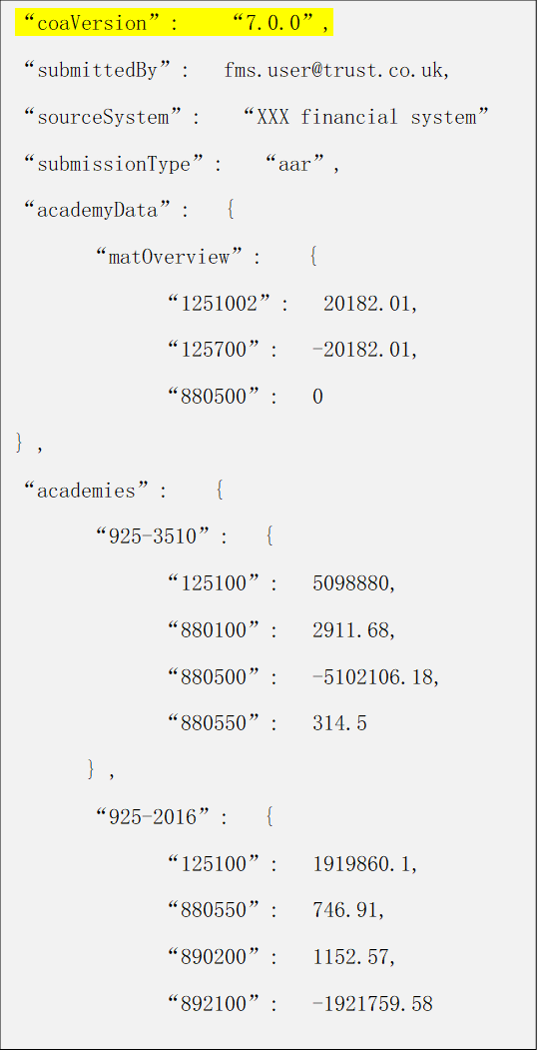

Format requirements
The API will reject any submission if the ACoA Version does not meet the necessary format:
- It requires 3 numerical parts, separated by 2 dots. Each part has a range:
  - 1st value: a number between 1 and 99999. It cannot begin with a zero. For example, 1, 11, 111, 1111, 11111 are all ok. 0, 01, 000 are not ok.
  - 2nd value: a number between 0 and 99999. Examples of ok values: 0, 00, 001, 1111, 11111
  - 3rd value: a number between 0 and 99999. Examples of ok values: 0, 00, 001, 1111, 11111
- Acceptable formats: 1.0.0, 1.00.000, 12.01.1, 134.001.001
- Rejected formats: 01, 01.aaa.bbb, 1.9999999.222222222

Version validation
There is a metadata table in our database which lists all ACoA uploads made. The most recent ACoA is marked as ‘active’ and the rest as ‘inactive’.
When a submission is made via the API, it will look up which ACoA is marked as ‘active’ and compare this against what has been submitted. The API will check the 1st digit only. If this digit matches the ‘active’ ACoA in the database, the submission will be permitted. Only the first digit is checked because variations of the second and third digits do not impact what account codes are sent via the API I.e., mapping changes (2nd digit change) or account description changes (3rd digit changes) will not impact the codes being sent.

ACoA version change logic
ACoA is published every year during spring on gov.uk. The ACoA version can change depending on the changes made to the ACoA for the financial year. We would avoid major changes whenever possible. The DfE team will communicate major changes, if any.
- Revision | - ACoA Change
- Major (1st digit) | - ACoA code change
- Minor (2nd digit) | - Mapping change  - Signage adjustment change  - Rounding account change  - Subtotalling of accounts change
- Maintenance – internal updates only (3rd digit) | - Description changes or reformatting

ACoA account code structure
Account codes are made up of 6 digits, with the first 5 digits being pre-set by the DfE, and therefore the account codes laid out in the published ACoA all end with a 0 (zero).

Using local account codes
The 6th digit may be used by a trust to set up 9 additional account codes against the DfE account code, therefore using 1 to 9 at the end of each DfE account code.
Trusts should not be able to alter/use the 5th digit of the account code, even if this has not been utilised by the DfE as:
- The automated mapping process will not pick these account codes up and the API will not be successful
- These are reserved for the DfE to add codes at a later date if needed

DfE ‘temporary’ account codes
The DfE have added 5 new ‘Temporary DfE’ account codes to the ACoA 2023/24, to allow for any unforeseen grants that must be reported on by academy trusts in the accounts return.
These accounts codes are:
- 510950 - Temporary DfE / ESFA revenue grants 1 (for DfE use)
- 510980 - Temporary DfE / ESFA revenue grants 2 (for DfE use)
- 510990 – Temporary DfE / ESFA revenue grants 3 (for DfE use)
- 520400 - Temporary other Government revenue grants - not DfE (for DfE use)
- 550600 - Temporary DfE / ESFA capital grants (for DfE use)
Trusts should not have access to these account codes unless the DfE stipulates a use for them, and at that time, the description and mapping will be updated.
The DfE will inform trusts and FMS providers in the event that one of the above account codes is bought into use. This change would affect a ‘minor (2nd digit)’ update to the version number as the account code already exists.
*510950 – has now been repurposed. We send you an e-mail in August 2024 to explain the action FMS suppliers will need to take:
***ACTION REQUIRED*** Account code 510970 for 2024/25:
- Change account code description from ‘Temporary DfE / ESFA revenue grants 1 (for DfE use)’ to ‘Core schools budget grant’
- Activate the account code on your trusts GL so that trusts can post income against the account code. If you have not added this account code to your GL structure, then please add and activate for 2024/25.
- Let trusts know that you have updated their GL for 510970; to change the description and activate the account code. We will be updating the academies CoA information on our webpages as soon as possible.
- Note AR mapping - currently no change, but this will be updated in due course once we know how this is to be reported to the DfE.
- Note BFR mapping – changed from field 135 ‘Other DfE/ESFA revenue grants’ to 102 ‘General Academy Grant (GAG) (excluding Student Service Grant)’

High level summary of ACoA code ranges
ACoA account code range | Description of account code range
100000 to 499999 | Trial balance – Balance Sheet
500000 to 899999 | Trial balance - Income and Expenditure (I&E)
900000 to 999999 | Not trial balance -  These are account codes allocated to additional information fields within the AR that are not linked to the trial balance, and therefore the mapping columns indicate the additional information trusts are required to provide over and above data that is pulled into the accounts return via automation. i.e. FMS providers DO NOT need to build these into their trusts ACoA

Glossary
Term | Description
Access token | Identifies a piece of information transmitted by a software system which contains the security credentials needed to call an API. The API can use the access token to check that the request is authorised.
API | Application Programming Interface: generic term for the method two computer systems use to interact.
AR | Accounts Return. This identifies a particular type of financial data collected by DfE once a year. This includes information from the trust financial accounts plus key supplementary information.
Bearer token | Generic term for the information transmitted during use of the API which identifies who is using the API. An access token is a specific example of a bearer token.
Academies Chart of accounts | This identifies the set of financial codes which data needs to be supplied against. Financial software products may either hold data against these codes or may provide a mapping from an existing coding structure.
Client ID | This identifies a unique code assigned to the software product and is used with most OAUTH interactions to identify the software product.
Client secret | This identifies a “password” which is assigned to a software product which wishes to use the API. For certain interactions this can be used to confirm the identity of the software product being used. This should be updated annually.
OAUTH | Industry standard for securing APIs. The standard allows a user to approve the use of an API for particular purposes.
Redirect URL | Identifies an address or addresses supported by the third-party software system. This must be pre-registered and is used to return secure information to the software system.
REST | Representational State Transfer: this identifies a type of API which allows the state of data resources to be read and changed via create, update or delete methods.
Subscription key | This is a unique cost assigned to the developer or organisation. This must be passed during the API and is used as a secondary check of authorisation as well as for operational monitoring and support.

HTTP status codes
This section describes the typical response codes received from requests. In the case of errors this also indicates potential reasons for the error.
Code | Response body | Typical reasons
200 | Submission data with the addition of the submission guid and datetime (utc) generated for this data. | Request was successful and the response typically shows the result.
204 | N/A | Request is successful but no response is returned (for example successful deletion of a resource)
400 | Application Error response | See Error Types Below
401 | Access denied due to missing subscription key. Make sure to include subscription key when making requests to an API. | Ensure you have provided a subscription key which is valid for the API you are calling. This needs to be as a header called Ocp-Apim-Subscription-Key.
401 | N/A | A valid bearer token was not provided.
403 | N/A | While a valid bearer token was not provided it was not issued by a member of the trust for which data is being submitted.
404 | Resource not found | The request was for a particular resource however that resource was not found. If this is for a particular submission ID, it is possible that the submission had previously been deleted. Alternatively, is the API path correct?
503 | Service unavailable | The API is temporarily unavailable because it is overloaded or down for maintenance. Please wait for a short time and try again.

API error codes
Http error code 400 / Bad Requests will provide an application error response formatted as follows:
{
"type": (error type), <-- String identifying error types
"details": (details) <-- String array providing additional details where applicable
}
The following table documents the possible error types:
Type | Details | Notes
coaValuePrecisionExceeds3dp | List of invalid ACoA items | One or more ACoA items has been provided with greater than three decimal places
invalidCoaCode | List of invalid ACoA items | One or more unrecognised ACoA items has been provided, or the ACoA item is located in an invalid place
invalidFormSubmissionStatus | None | The trust is not yet setup by the DfE for accepting FMS submissions
invalidRequestBody | None | Invalid JSON data provided in request body
newFmsSubmissionsClosed | None | The trust has submitted their AR form data to the approval process, so FMS submissions are no longer accepted
requestBodyMissing | None | The request body is missing
schemaValidation | Dev only (see notes column) | Any json schema violation will trigger this error. During development, use of the Enable-Dev-Error-Details=true header will enable schema violation details in the response.
trustDataNotInBalance | None | Trust data provided within the request must balance.
unknownAcademy | List of unknown academies | During development, use of the Enable-Dev-Error-Details=true header will enable list of known academies in the response.
unknownCoaVersion | None | The provided CoA version is not known
unknownException | Dev Only | Any exception not covered above. During development, use of the Enable-Dev-Error-Details=true header will display technical error details.

AR203/24 release changes
There are no changes made to the consent process for the AR2023/24 release
List of changes in the submission API –
- ACoA version for AR2023/24 is “6.3.0”
This version number is subject to change prior to the release of the AR 2023/24. There will be no new or deleted account codes in later versions, and changes would only apply to mapping, signage or descriptions.
Please refer to FMS API validations in Appendix section for details of all validations.
Refer to the document control section to review which areas of this guide have been impacted.

Document control

Version | Date Issued | Brief summary of change
0.1 | 24/05/2019 | Initial draft
0.2 | 30/05/2019 | Revised draft
0.3 | 07/06/2019 | Update
0.4 | 11/7/2019 | Revised with final code changes
0.5 | Nov 2019 | Updated
0.6 | 22/04/2020 | Enhanced to clarify operation of API.
0.7 | 23/04/2020 | - Clarified the operation of the API.  - Improved description of parameters.  - Added more detailed description of errors.
0.8 | 24/04/2020 | Performed various cosmetic updates following review by TC.
0.9 | 27/04/2020 | Performed updates following review by AB, JH & AS
1.0 | 01/05/2020 | - Clarified selected explanation text  - Added glossary.  - Clarified position regarding counterparties for next release of API  - Update API endpoint to new location
1.0.1 | 06/05/2020 | Removed tracked changes and further clarified use of multiple URLs and number of decimal places.
1.0.2 | 07/05/2020 | Correct couple of typos
1.1.0 | 26/06/2020 | API version 1.1 request and error response updates
1.1.1 | 16/07/2020 | Updated return codes and error types
1.1.2 | 23/07/2020 | Updated to include OAuth 2.0 process; Update API to remove the need to provide Company Number as query parameter.  Merged the two documents issued most recently on Thursday 16th July 2020.
1.1.3 | 07/08/2020 | Updated the api_base_url in the key environment variable section  Replaced authorisation_base_url with two separate authorise_base_url and token_base_url.  Added environment key variables for UAT
1.1.4 | 11/08/2020 | Added unknownException API error type  Step 1: Invoke authorisation – updated scope to include additional parameter {fms_api_scope_url}  Step 3 & 4: Added additional code for scope parameter  Updated environment key variables for {fms_api_scope_url}
1.1.5 | 18/08/2020 | Updated value of the scope in step 3: Exchange authorisation code for access token
1.1.6 | 22/10/2020 | Added numbering scheme for the section “Data Requirements for Submission”  Added points 4,5 and 6 to the section “Data Requirements for Submission”
2.0.0 | 31/03/2021 | A new version for the AR2021 collection –  Sections updated –  Registering your software product  Data requirements for Submission  Data Validation  Request Body – Schema, Example body and Sample json  AR2021 Release changes  Appendix – FMS API Validations
2.1.0 | 14/09/2021 | Sections updated –  Registering your software product  Key Environment Variables  API Version  New Sections added -  Data Set Information  ACoA Version
3.0.0 | 11/03/2022 | Sections updated -  - Data requirements  - Data set information  - Release changes
4.0.0 | 30/06/2022 | Sections updated –  - Overview – new sections for:  - Timelines  - Draft trust financial statements  - Data requirements update – points added for:  - MAT central services  - DfE account codes  - Trading subsidiaries  Note: these are not new requirements, but added for clarity  - Step 1: Invoke the Authorisation endpoint – updated consent statement screen shot  - AR2022 release changes  New Sections added -  - Draft trust financial statements
5.0.0 | 24/05/2023 | New section added –  - Annual update of client secret ID’s
5.0.0 | 24/05/2023 | New section added –  - ACoA account code structure
6.0.0 | 26/09/2024 | New sections added -  - 2 sections relating to Budget Forecast Returns  - The importance of trust status and data types  - Test accounts  Section removed -  - UAT environment sections and links removed  Other -  - Updates to environment links in Appendix > API Details section  - Updated links in ‘Supplier test (STE)’ section  - API base URL for STE  - Front end on-line collections STE URL  - Scope URL changed from preprod to prod tenent  - New link to our supplier helpdesk addedink for developer hub changed to ‘Find and Use an API’  - Update to DfE temporary account codes  - Wording change from ‘CoA’ to ACoA’ throughout. (Academies chart of accounts to differentiate from further education CoA)  - Name changed from ‘Developer hub’ to ‘Find & Use an API’  - Link for developer hub changed to ‘Find and Use an API’

Appendix

FMS API validations
The following explains the validation and responses of the json request data that is sent via the API.
Validation errors are returned as http status code 400 “Bad request”. The response body will be a json message. It has a field called “type” which is used to indicate what type of error it is returning.
Example: The following is a schema validation error where zero was passed as a value.
{
"type": "schemaValidation"
}

In development, a http header can be set which may result in a more detailed explanation of the error.
http header: Enable-Dev-Error-Details=true/false
With the header set to true the json response now looks like this:
{
"type": "schemaValidation",
"details": [
"Path 'academyData.academies.925-2016.125100', Line: 9, Position 27, Error: Value 0 is not allowed"
]
}

There are 2 types of validation being applied to the request.
- Json schema validation
- Data validation
They are evaluated separately. This means if a json schema validation error is found, it will not be passed to the data validation. As a result, errors are group by type.
If the request has schema errors, then it is considered ill formed and as such data validation may give misleading results.

Json schema validation
In this validation, a schema is used to specify the general format of the data. What fields are allowed, the lengths, upper/lower limits, which fields are mandatory etc. We refer to this as structural/format validation.
The following are validations at this level.
- Duplicate key
For the most part, json can be considered as a series of key/value pairs. The key represents a property, and the value is the value for the property.
Example. {"name": "Bugs Bunny", "age": 30}
The above json has 2 keys name and age.
An example of duplicate keys: {"name": "Bugs Bunny", "name": "Elma Fudd", "age": 30}

This has 2 “name” keys, which is used to specify the name? Why does it have 2 names? Is that intentional, a mistake? People will have different views. Given it is therefore not clear what the meaning is, duplicate keys are not allowed.
With the dev error details enabled, the error will tell you which key and the location.
{
"type": "schemaValidation",
"details": [
"Path 'academyData.academies.925-2016', Line: 11, Position 23, Error: Property with the name '925-2016' already exists in the current JSON object."
]
}

Current limitations: Only the details of the first duplicate are returned. This is only an issue with dev errors enabled as errors messages are not included in when not enabled.

- Zero values
All values must be supplied as either a negative or positive number. No values can be passed as zero or variations of.
The following are all “zero”.
- 0
- 0.0
- 0.00
Example:
Input: "925-2016": {"125100": 0}
Response (with dev errors enabled):
{
"type": "schemaValidation",
"details": ["Path 'academyData.academies.925-2016.125100', Line: 9, Position 27, Error: Value 0 is not allowed"]
}

- Upper/lower limits
All numerical values need to be with in a specific numeric range. Any values outside of this range will trigger an error.
Allowed range: -999999 and 999999 (excluding zero)
Example:
Input: "925-2016": {"125100": -99999999}
Response (with dev errors enabled):
{
"type": "schemaValidation",
"details": [
"Path 'academyData.academies.925-2016.125100', Line: 9, Position 35, Error: Integer -99999999 is less than minimum value of -999999. Integer -99999999 is less than minimum value of 0."
]
}

Input: "925-2016": {"125100": 99999999}
Response (with dev errors enabled):
{
"type": "schemaValidation",
"details": [
"Path 'academyData.academies.925-2016.125100', Line: 9, Position 34, Error: Integer 99999999 exceeds maximum value of 0. Integer 99999999 exceeds maximum value of 999999."
]
}

Current limitations: The way ranges are implemented in the schema creates 2 different messages based on the value passed. Both refer to exceeding 2 numbers. This is being looked at to create a simpler error. This is only an issue with dev errors enabled as errors messages are not included in when not enabled.

- Number of decimal places
All numeric values must be between 0 and 3 decimal places.

Valid values example: 1, 2.0, 3.14, 6.666, 2.000
Invalid values example: 1.0000, 2.0000000, 3.141592, 6.6661
Input: "925-2016": {"125100": 1.0001}
Response (with dev errors enabled):
{
"type": "schemaValidation",
"details": [
"Path 'academyData.academies.925-2016.125100', Line: 9, Position 32, Error: Float 1.0001 exceeds maximum value of 0. Float 1.0001 is not a multiple of 0.001."
]
}

Not a multiple of .001 simply means it exceed 3 decimal places.

The only exception is when the number of decimals exceeds 3 but the value can be changed to 3 without altering the value. This means no loss of data through rounding occurs.
Examples:
1.0000000 can be reduced to 1
1.0010000 can be reduced to 1.001

- Mandatory fields
Certain fields have been marked as mandatory. Failure to send them will result in a schema validation error.
Example, the coaVersion key is required. I the json request does not send this data, the following error is returned.

Input (missing coaVersion): "{"academyData": { … } }

Response (with dev errors enabled):
{
"type": "schemaValidation",
"details": ["Path '', Line: 1, Position 1, Error: Required properties are missing from object: coaVersion."]
}

The current mandatory fields are:
- coaVersion
- academyData
- trustData
- submittedBy
- submissionType
- sourceSystem

- Regular expressions (Regex)
Several fields are checked to ensure they match certain lexical patterns. This is performed using a “regular expression”. The expressions check length / characters used etc.

The current expressions used are:

Field | Pattern | Meaning | Example
Academy LAE | ^[0-9]{3}-[0-9]{4}$ | 3 digits followed by a dash followed by 4 digits. Digits allowed are 0 to 9. Nothing else can be part of the value. | Good: 123-4567  Bad: A23d-44er
COA Code | ^[0-9]{6}$ | 6 digits. Digits allowed are 0 to 9. Nothing else can be part of the value. | Good: 123456  Bad: A23d-44er
Submitted by | ^[^<>\\[\\]{}/'#:!=|&+\\*?^$]+$ | None of the characters in the expression. | Need to verify this
Source system | ^[a-zA-Z0-9-\\&\\. ]+$ | One or more characters. Characters allowed are A to Z (upper and lower case), Dash (-), Ampersand (&), Period (.) or a space. | Good: Acme & Sons FMS V1.2  Bad: Acme #V1.2 $$$

- Unknown / additional keys
The request must not send any additional keys not already defined in the schema. The only exception is the academy LAE numbers and COA codes.

This means you cannot send extra information as the processor is not expecting it.

The following is the expected structure.
{
"coaVersion": "3.0.0",
"academyData": {
"matOverview": {
"115100": 50.00
},
"academies": {
"925-2016": {
"125100": 1.01
}
}
},
"trustData": {
"125100": 1,
"125200": -1
},
"submittedBy": "TestUser",
"submissionType": "aar",
"sourceSystem": "DfE FMS Supplier System"
}

Example: Adding a coaDescription key.

Input:
{
"coaVersion": ".0.0",
"coaDescription": "Some description text",
"academyData": {…},
"trustData": {…},
"submittedBy": "TestUser",
"submissionType": "aar",
"sourceSystem": "DfE FMS Supplier System"
}

Response (with dev errors enabled):
{
"type": "schemaValidation",
"details": [
"Path 'coaDescription', Line: 3, Position 21, Error: Property 'coaDescription' has not been defined and the schema does not allow additional properties."
]
}
All schema validation errors are returned with a type of “schemaValidation”.

Data validation
In this validation, the actual values are validated. This group of validations is only checked once the json schema validation is successful. Note, there are several checks here that are now covered by the json schema check and will therefore not be executed unless the data validation is executed manually.

- CoA Version
The coa version is checked to see if it matches an entry in the database. Passing a version that is not supported will result in an unknown coa version error.

Input:
{
"coaVersion": "9999.0.0",
"academyData": {…},
"trustData": {…},
"submittedBy": "TestUser",
"submissionType": "aar",
"sourceSystem": "DfE FMS Supplier System"
}

Response:
{
"type": "unknownCoaVersion"
}

- CoA codes
The coa codes are checked to ensure they are supported. Passing a code that is not supported will result in an unknown coa code error.

Input:
{
"coaVersion": "~2",
"academyData": {
"matOverview": { … },
"academies": {
"925-2016": {
"888888": 1.01
}
}
},
"trustData": { … },
"submittedBy": "TestUser3",
"submissionType": "aar",
"sourceSystem": "DfE FMS Supplier System"
}

Response (with dev errors enabled):
{
"type": "invalidCoaCode",
"details": [
"925-2016.888888"
]
}

- CoA value data type
The values passed with the coa codes are checked to ensure they are numeric. Passing a non-numeric value result in an invalid value type error.

Note: This check is covered by the json schema validation.

Input:
{
"coaVersion": "~2",
"academyData": {
"matOverview": { … },
"academies": {
"925-2016": {
"125100": "1.01"
}
}
},
"trustData": { … },
"submittedBy": "TestUser3",
"submissionType": "aar",
"sourceSystem": "DfE FMS Supplier System"
}

Response (with dev errors enabled):
{
"type": "coaValueInvalidType",
"details": [
"925-2016.125100"
]
}

- CoA value decimal places check
The values passed with the coa codes are checked to ensure they have no more than 3 decimal places. Passing a value with more than 3 decimal places will result in a precision exceeded error.

Note: This check is covered by the json schema validation.

Input:
{
"coaVersion": "~2",
"academyData": {
"matOverview": { … },
"academies": {
"925-2016": {
"125100": 1.000001
}
}
},
"trustData": { … },
"submittedBy": "TestUser3",
"submissionType": "aar",
"sourceSystem": "DfE FMS Supplier System"
}

Response (with dev errors enabled):
{
"type": "coaValuePrecisionExceeds3dp",
"details": [
"925-2016.125100"
]
}

- Trust data balance check
The values in the trust data section need to balance. In order to balance, the values must total zero. All values where their coa code does not start with a 9 are involved.

In the following example, only the first 2 codes are used and the 3rd is excluded from the sum. The result is zero as 1 + -1 = 0

"trustData": {
"125100": 1,
"125200": -1,
"900100": 1
}

Input:
{
"coaVersion": "~2",
"academyData": { … },
"trustData": {
"125100": 1,
"125200": 1,
"900100": 1
},
"submittedBy": "TestUser3",
"submissionType": "aar",
"sourceSystem": "DfE FMS Supplier System"
}

Response:
{
"type": "trustDataNotInBalance"
}

In the above example, the 3rd value is excluded, and the first 2 fields are used. However, the total is 2 (1 + 1) and not zero.

API Details
STE Environment:
- STE Application Link (front end) : https://onlinecollections-ste.education.gov.uk
- STE API Submission Link: https://oat-api-customerengagement.platform.education.gov.uk/fmssuptest/api/submissions
- STE Token End Point : https://dfeb2cprod.b2clogin.com/dfeb2cprod.onmicrosoft.com/oauth2/v2.0/token?p=B2C_1A_consent_dfe_ste
Prod Environment:
- Prod Application Link (front end) : https://onlinecollections.education.gov.uk/
- Prod Submission Link: https://education-financial-reporting.api.gov.uk/fmsprod/api/submissions
- Prod Token End Point: https://dfeb2cprod.b2clogin.com/customeridentity.education.gov.uk/oauth2/v2.0/token?p=B2C_1A_consent_dfe

